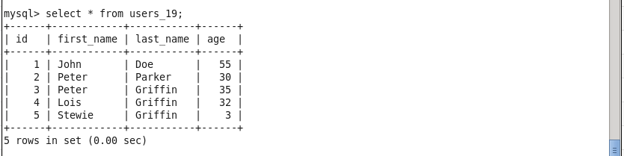

Directory /tmp_19/00

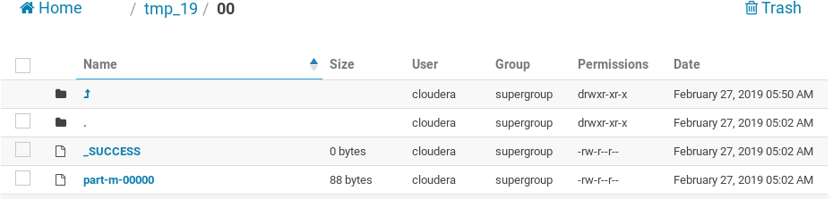

Contents of the file part-m-00000

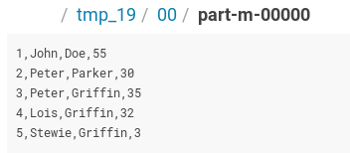

Directory /tmp_19/01

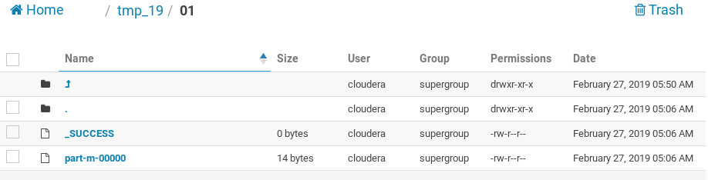

Contents of the file part-m-00000

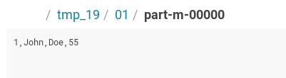

Directory /tmp_19/01

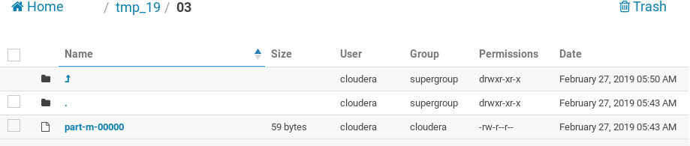

Contents of the file part-m-00000

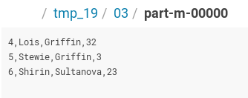

Result of the query SELECT * FROM hive_student_19.users_19 (Hive)

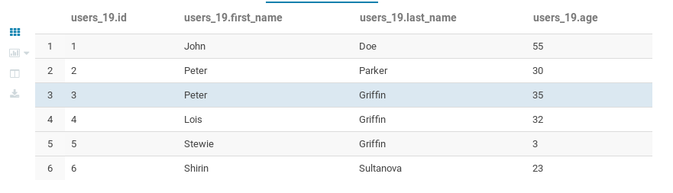

Result of the query SELECT * FROM hive_student_19.users_19 (mysql)

